­

Aplikasi Konversi suhu menggunakan Visual Basic

1. Celcius To Farenheit
2. Farenheit To Reamur
3. Reamur To Kelvin

**Nama : Ibnu Hasan**

**Nim : 200511148**

**Kelas : TI20D**

**MK : Pemrograman Visual**

**Source Code**

1. **Celcius To Farenheit**

Public Class Form1

Private Function KonversiCelciustoFahrenheit(c As Integer) As Integer

Dim f As Integer

f = (9 / 5 * c) + 32

Return f

End Function

Private Sub btnkonversi_Click(sender As Object, e As EventArgs) Handles btnkonversi.Click

Dim c, f As Integer

c = Val(txtcelcius.Text)

f = KonversiCelciustoFahrenheit(c)

txtfahre.Text = Str(f)

End Sub

End Class

**Hasil Konversi Suhu Celcius to Fahrenheit**

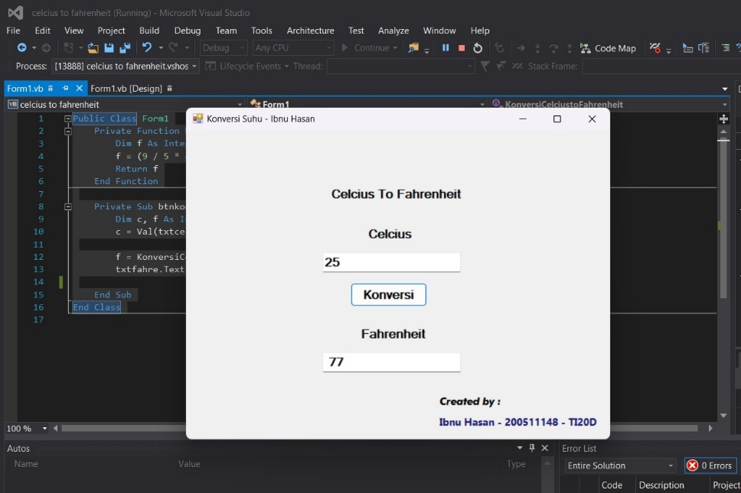

1. **Fahrenheit to Reamur**

Public Class Form1

Private Function KonversiFahrenheittoReamur(f As Integer) As Integer

Dim r As Integer

r = (4 / 9) * (f - 32)

Return r

End Function

Private Sub btnkonversi_Click(sender As Object, e As EventArgs) Handles btnkonversi.Click

Dim f, r As Integer

f = Val(txtfahre.Text)

r = KonversiFahrenheittoReamur(f)

txtreamur.Text = Str(r)

End Sub

End Class

**Hasil Konversi Suhu Fahrenheit to Reamur**

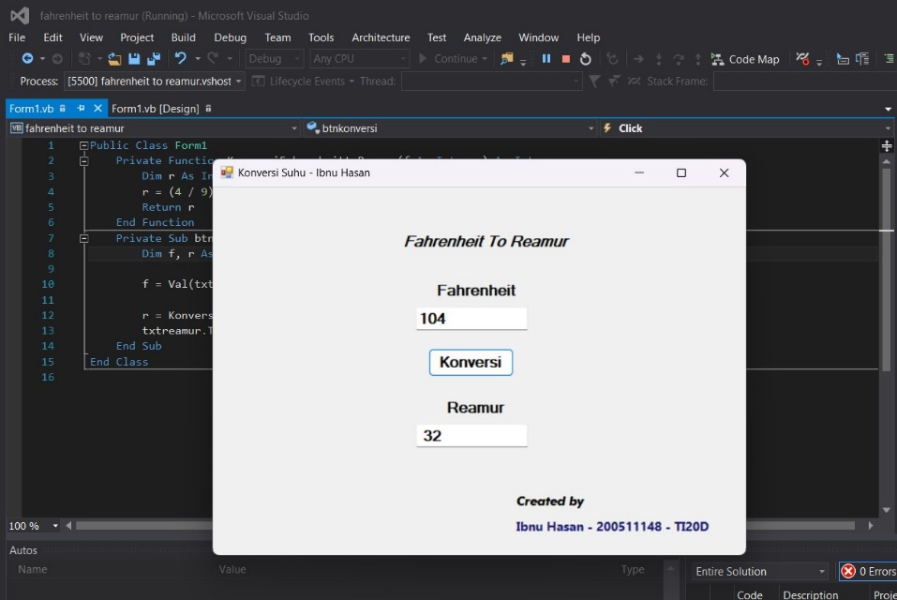

1. **Reamur to Kelvin**

Public Class Form1

Private Function KonversiReamurtoKelvin(r As Integer) As Integer

Dim k As Integer

k = (5 / 4 * r) + 273

Return k

End Function

Private Sub btnkonversi_Click(sender As Object, e As EventArgs) Handles btnkonversi.Click

Dim r, k As Integer

r = Val(txtreamur.Text)

k = KonversiReamurtoKelvin(r)

txtkelvin.Text = Str(k)

End Sub

End Class

**Hasil konversi suhu reamur to kelvin**

